**\*NOTE: THIS IS A WORK IN PROGRESS\***

**If you have any questions, feel free to contact me @**

[**benmercer76@btinternet.com**](mailto:benmercer76@btinternet.com)

All images displayed, other than the original photos, are designed by me, Ben Mercer, as of October 23’ these photos are actively posted on Play2Day’s [Instagram](https://www.instagram.com/play2dayipswichinsta/) & [Facebook](https://www.facebook.com/play2dayipswich/) accounts, Hyperlinked Respectively.

Table of Contents

Planner / Timetable 9

Area Appreciation posts 14

October Half Term 15

Slideshow posts 17

|  |  |  |
| --- | --- | --- |
| **Original Post** | **First Improvement** | **Final Design** |
|  |  |  |
| **Original Post** |  | **Final Design** |
|  |  |  |
| **Original Post** | **Alternate Design (For Frantic Friday)** | **Final Design** |
|  |  |  |
| **Original Post** | **Final Design** | **Alternate Design** |
|  |  |  |

|  |  |  |
| --- | --- | --- |
| **Original Post** | **Final Design** | **Alternate Design** |
|  |  |  |
| **Original Post** |  | **Final Design** |
|  |  |  |

* **As well as these posts, I have made some ones fully on my own:**

|  |  |  |  |
| --- | --- | --- | --- |
| **These posts are designed to advertise the new accounts for Play2Day that have been created, mainly to raise awareness and followers.** | | | |
|  |  |  |  |

|  |  |  |  |  |
| --- | --- | --- | --- | --- |
| **Here are some “Stories” designed and posted on Instagram, I adapted the theme of a post, but turned it into multiple stories that are posted a day before the event happens.** | | | | |
|  |  |  |  |  |

* **Here’s another post I made on my own, a review from a child, this was posted as a story:**

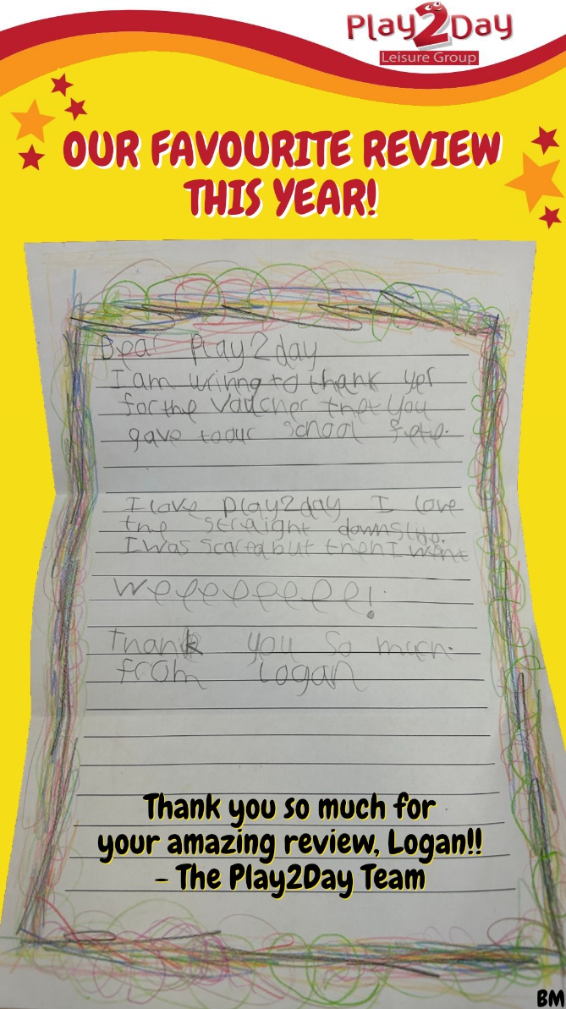

# Planner / Timetable

* I also designed a Timetable to be used over the school term, to keep parents informed about what is happening over the school year:

* Heres an alternate design I made for the October Half Term:

* **Laser Tag – I made a new** “Rules” screen **that displays the rules of play on an old TV which wasn’t being used until I had the idea.**
* **These rules are now played in conjunction to a LIVE scoreboard, which the winner of the match is added into and the leaderboard updates as a new score is added, updating on the TV almost immediately.**

|  |  |  |  |  |  |
| --- | --- | --- | --- | --- | --- |
|  |  |  |  |  |  |

* **I was also commissioned to design some** 9:16 aspect ratio posts**, to be displayed on a screen inside the Centre, here are my finished designs:**

Area Appreciation posts**, these posts, completely designed, and made by me have a been a major hit for engagement with the viewers. I have chosen to take photos of the four different areas / Unique Selling Points , Laser-Tag, Inflatable, Play Structures and Tiny Tots.**

**The links to each post will be placed here:**

|  |  |  |  |
| --- | --- | --- | --- |
| [**Tiny Tots**](https://business.facebook.com/play2dayipswich/posts/pfbid0vMnfLn7miVqnFYbMNzsmC5W94V22MjVGK2gtD8wNGv84aLQHGTYAWBjzNWZX2PcAl) | [**Main Play Structure**](https://www.facebook.com/play2dayipswich/posts/pfbid0C8ZaD6fvJiRNRNDRtKVrpy4SXQqJxvf5Q8uLwWAzTJ6P3kTrVHHbaNyNAbnnbySdl) | [**Inflatable**](https://www.facebook.com/play2dayipswich/posts/pfbid05hPdjM6vEAsV6b1zFyt1exY93TjXPNDFrdwogqsbSGmDbr1TkcxggQJ4SjWbXk2Ml) | **Laser-Tag** |

# October Half Term

* I made some posts for the October half term:

# Slideshow posts

These posts are made to engage the user by allowing them to see multiple different events:

<https://www.facebook.com/photo/?fbid=800055798797514&set=pcb.800055838797510>

<https://www.facebook.com/photo/?fbid=796974282438999&set=pcb.796974359105658>

<https://www.facebook.com/photo/?fbid=796716189131475&set=pcb.796716229131471>

# A collage of images of a game Description automatically generatedA yellow and red flyer with balloons and stars Description automatically generatedA yellow gift voucher with red and blue text Description automatically generatedA collage of images of a laser tag Description automatically generatedA laser tag with neon lights Description automatically generated